Week Ending: |  | DAY: |  |  |  | Subject: History
Duration: 60mins per lesson |  |  |  |  |  | Strand: My Country Ghana
Class: B2 |  | Class Size: |  |  |  | Sub Strand: Some Selected Individuals
Content Standard:  B2.2.5.1.1 Exhibit understanding of Ghanaian women who have contributed significantly to Ghana’s development |  |  |  |  | Indicator:  B2.2.5.1.1. identify Ghanaian women who have made significant contributions to national development. |  |  |  | Lesson:  1 OF 1
Performance Indicator:  Learners can identify Ghanaian women who have made significant contributions to national development. |  |  |  |  |  |  | Core Competencies:  Global citizenship, and digital literacy
Teaching/ Learning Resources |  |  | Pictures and charts
New words
References: History Curriculum Pg. 10
DAY | PHASE 1: STARTER |  |  | PHASE 2: MAIN |  |  |  | PHASE 3: PLENARY
 | Review learners understanding in the previous lesson using questions and answers.  Show pictures of Justice Georgina Wood to learners for to talk about it  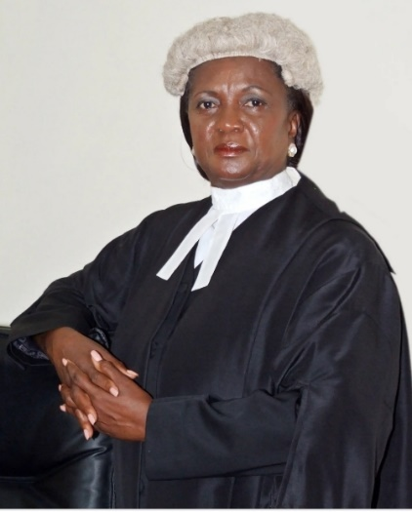  Engage learners to play games and sing songs to begin the lesson. |  |  | Guide learners to name some outstanding women in the history of Ghana e.g. Justice Georgina Wood – First female Chief Justice  Georgina Theodora Wood  Georgina Theodora Wood is a Ghanaian judge and also a former police prosecution officer. She was the chief justice of Ghana and the first woman to occupy that position. She was born on 8 June 1947. She had her basic education at Bishop’s girls and Methodist schools. She proceeded to the university of Ghana, Legon, where she was awarded the LL.B in 1970. She was appointed to the supreme court by President John Kufour on 12 November 2002. She was nominated for the position of chief justice of Ghana in May 2007. |  |  |  | Ask learners series of questions to review their understanding of the lesson  Ask learners to summarize what they have learnt  Learners to read and spell the key words on the board.
 | Review learners understanding in the previous lesson using questions and answers  Engage learners to play games and sing songs to begin the lesson. |  |  | Using pictures let learners retell the contributions of Justice Georgina Wood to national development  Think pair-share-activity: Individual learners identify a woman who they admire most in the community.  They choose partners and discuss the reasons for their choice. |  |  |  | Ask learners series of questions to review their understanding of the lesson  Ask learners to summarize what they have learnt

